Shell Tutorial

**Part -4 (Bash Files)**

1. **nano** – This command is used to edit the content of the file.

If you want to change the content of a file, you can simply use this command

“nano <file_path>”, then you can make the desired changes.

Like here I have added a new row in the temp.csv file, highlighted in the screenshot below,

nano temp.csv

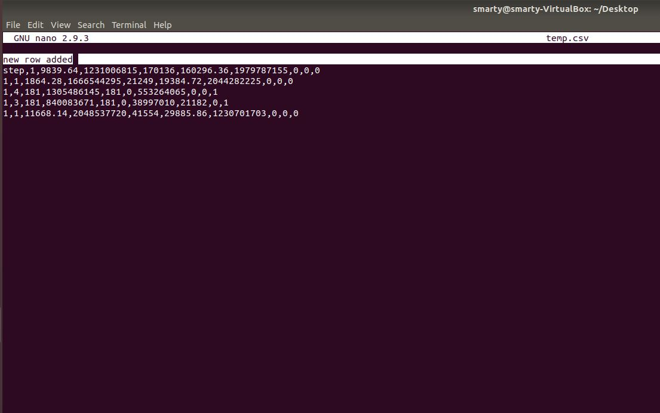

Once you are done with the changes then you will some commands at the bottom, so

Here I have used to command (Ctrl + O) to write the file, then it will ask for a file name 🡪 if you want the keep the files name as same then simply press enter or else you can give the new name.

Once I was done with this command, I want to get out of this window so for that, I have used (Ctrl + X) command to do so.

C:\Users\smarty\Desktop\4\3.JPG

Here a new row got added in the file.

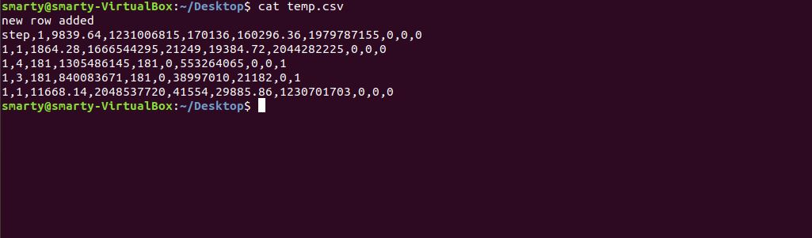

1. **Bash Files –**

Here I have created a shell file “bash.sh” which will give all the first three rows of the datasets

I create a file using the command “nano bash.sh”

C:\Users\smarty\Desktop\4\5.JPG

In this file I put a command “head –n 3 /home/smarty/Desktop/*.csv”

That will filter all the first-three rows of the .csv files present on the desktop.

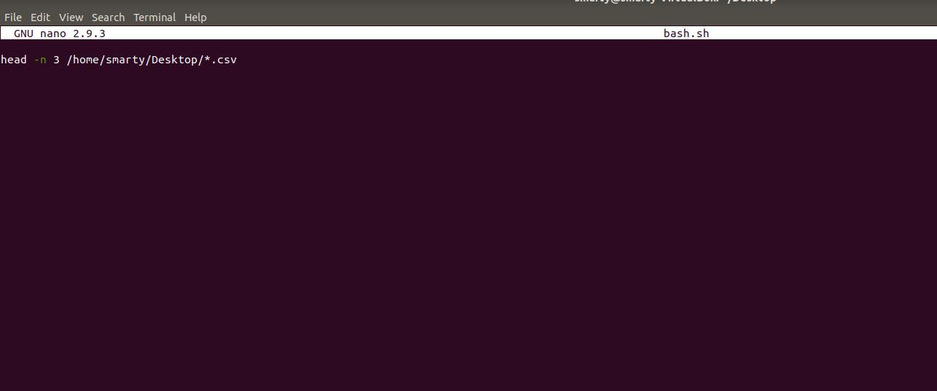

Check the output-

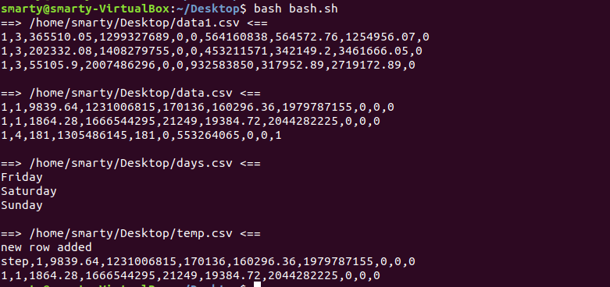

As we are having Four .csv (‘data1.csv’, ‘data.csv’, ‘days.csv’, ‘temp.csv’) files present on the Desktop so it will display the first 3 rows of all the files.

1. **Bash Files with parameters –** If you want to make a script for dynamic files or the dynamic number of rows, then you can use the concept of parameters in bash files.

Like here, I have created a bash file named “bash_parametrs.sh” which will filter the columns of the dataset.

C:\Users\smarty\Desktop\4\8.JPG

Here I put the command “cut –d , -f $2 $1 ” this command will filter the column which will be given in the parameter($2 parameter) and from the file $1 (file name given in the parameter).

Here

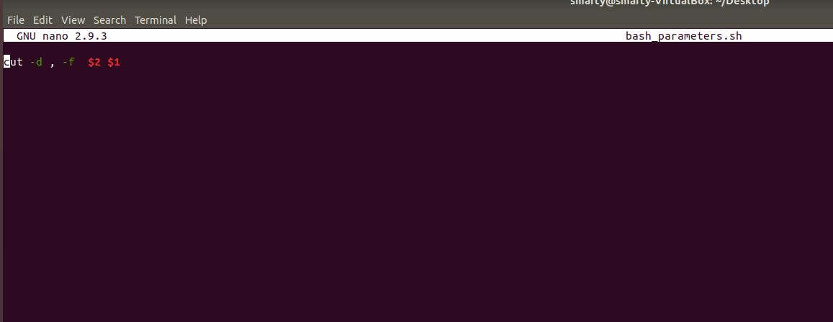

Here I gave the file name as “/home/smarty/Desktop/data.csv” which will get stored in $1 and column number as “3” which will get stored in $2.

Hence my command inside bash file will become “cut –d , -f 3 /home/smarty/Desktop/data.csv”

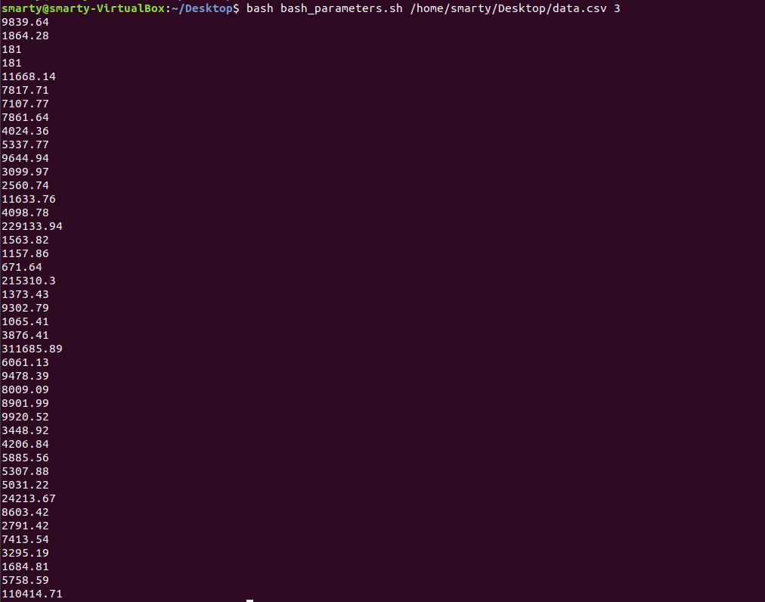

You can compare the output with the actual data.csv file whose third column is the same as we got in our output.

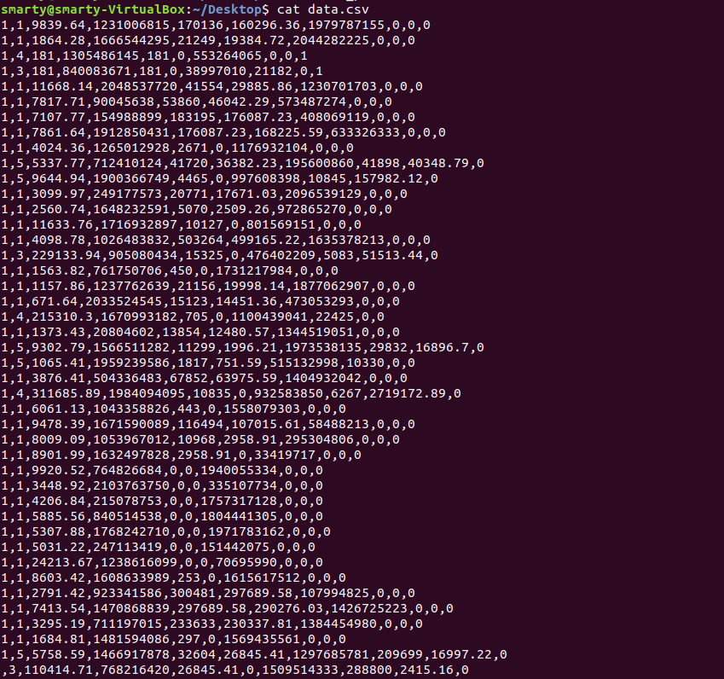

1. **For loop inside a shell script –** If you want to make a for loop for dynamic files inside a shell script(bash file), you can do so by following this simple procedure,
2. Create a bash file with any name, let’s say here I took the name as “bash_loop.sh”

Command – “nano bash_loop.sh”

C:\Users\smarty\Desktop\4\12.JPG

1. Write the code inside that bash file, as here I want to filter the first and last row of the file, so I make the code as

*“for name in $@*

*do*

*head -n 2 $name*

*tail -n 1 $name*

*done“*

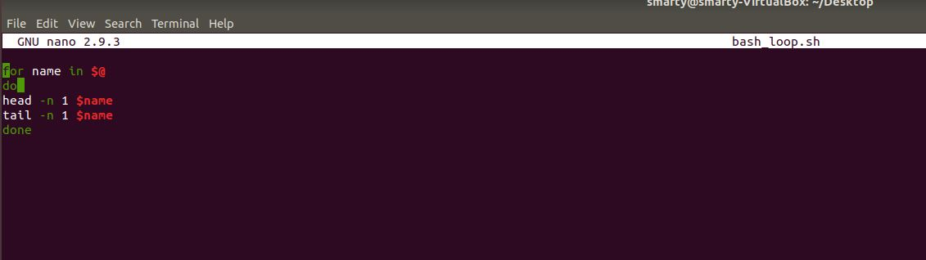

1. Now it’s the time to check the script for which you have to run the command “bash <file_name> <parameters if any>”

“*bash bash_loop.sh /home/smarty/Desktop/data.csv* ”

C:\Users\smarty\Desktop\4\14.JPG

You can check the output by comparing it with the actual data.csv file

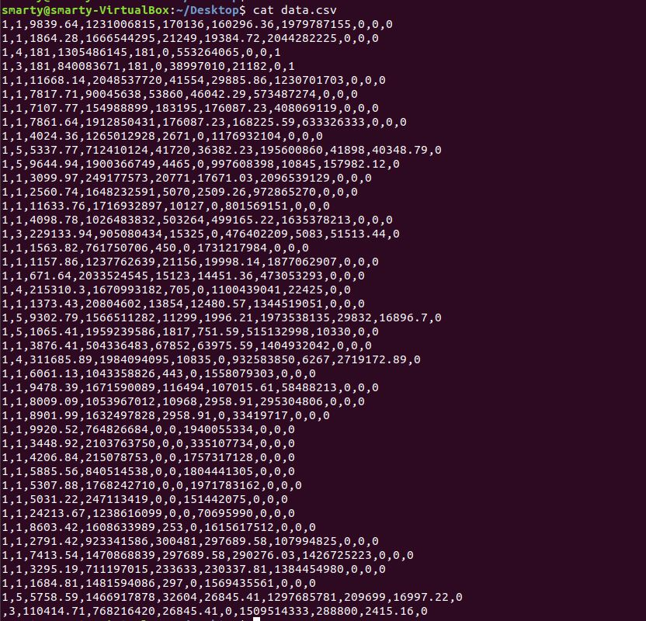

Created by Vidit